**AquaSafe**

**WSL20**

**Water Safety**

**Laboratory**

**Instruction Manual**

# Contents

## Section 1: Introduction

## Section 2: Kit Contents

## Section 3: Single Incubator Instructions

## Section 4: Membrane Filtration Instructions

## Section 5: Turbidity Tube Instructions

## Section 6: Block Tester Instructions

# Section 1: Introduction

The AquaSafe® WSL20 is a fully portable field laboratory for the detection of microbiological and physico-chemical water quality parameters.

The lab is housed in a waterproof carry case and comprises the following:

* Integrated single chamber digital incubator complete with all accessories and consumables for carrying out 300 tests for Faecal and Total Coliforms.
* Block Tester complete with consumables for 300 tests of Free & Total Chlorine and pH.
* Turbidity Tube for turbidity testing in the range 5 to 500NTU.

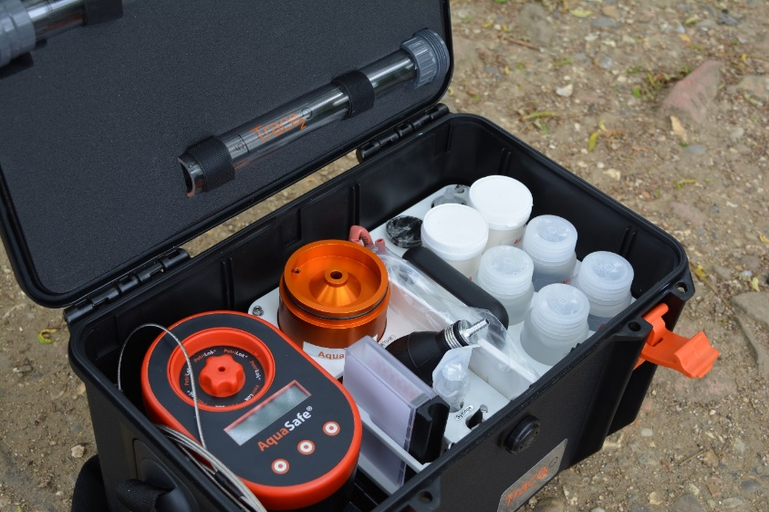

# Section 2: Kit Contents

H

G

K

I

J

F

Evv

D

C

B

B

A

A

A

A

13

12

11

10

9

8

7

6

6

5

4

3

2

1

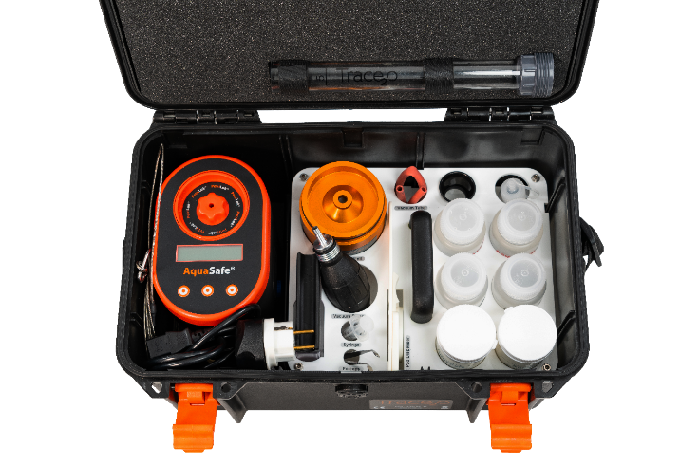

# Main Case Components

|  |  |  |
| --- | --- | --- |
| **Item** | **Qty** | **Description** |
| **1** | **1** | **AquaSafe® Single Incubator** |
| **2** | **1** | **PetriLok® Cassette with cap and 25 Aluminium Petri Dishes** |
| **3** | **1** | **2 Part Turbidity Tube 5-500NTU** |
| **4** | **1** | **5 metre Sampling Cable with Carabiner** |
| **5** | **1** | **12V 4A Lead Acid Charger/Power Supply** |
| **6** | **1** | **IEC Mains Cable - UK** |
| **6** | **1** | **UK to EU Adapter** |
| **7** | **1** | **Vehicle Charging Cable** |
| **8** | **1** | **Multipurpose Screwdriver** |
| **9** | **1** | **Digital Thermometer** |
| **10** | **1** | **Silicone Grease** |
| **11** | **1** | **Calibration Pack** |
| **12** | **4** | **Membrane Lauryl Sulfate Broth Sachet** |
| **13** | **4** | **Dechlorination Tablet Bags (Whirl-Pak)** |

## Tray Components

|  |  |  |
| --- | --- | --- |
| **Item** | **Qty** | **Description** |
| **A** | **4** | **Sterilised Water for Membrane Lauryl Sulfate Broth Preparation** |
| **B** | **2** | **Sterile Absorbent Pads (100 Pack)** |
| **C** | **1** | **Pad Dispenser** |
| **D** | **1** | **Forceps** |
| **E** | **1** | **5ml Sterile syringe** |
| **F** | **1** | **Pool Tester** |
| **G** | **1** | **Vacuum Pump** |
| **H** | **1** | **Membrane Filtration Unit including, waste beaker, sample beaker, measuring funnel, sintered glass disk & 1 silicone gasket** |
| **I** | **1** | **Vacuum Tube** |
| **J** | **1** | **Eyeglass** |
| **K** | **1** | **30ml Dropper Bottle for Methanol** |

## Separate Box

|  |  |
| --- | --- |
| **Qty** | **Description** |
| **3** | **Sterile Membrane Filters (100 Pack)** |
| **1** | **Sterile Absorbent Pads (100 Pack)** |
| **3** | **HP1 Phenol Red Rapid Tablets (100 Pack)** |
| **3** | **HP2 DPD No.1 Rapid Tablets (100 Pack)** |
| **3** | **HP3 DPD No.3 Rapid Tablets (100 Pack)** |
| **1** | **Cotton Drawstring Bag** |

**Section 3**

**AquaSafe**

**Micro-biological Incubator**

**Instruction Manual**

# Contents

**1.0 Introduction 12**

**2.0 Incubator set-up 13**

**2.1 Docking Station 13**

**2.2 Battery Removal 14**

**2.3 Battery Charging 14**

**2.4 Vehicle Power 15**

**2.5 Fuse 15**

**3.0 Operating instructions 16**

**3.1 Incubator controls 16**

**3.2 Getting started 17**

**3.3 Menu Options 17**

**3.3.1 Menu sequence 18**

**3.3.2 Start Screen (Figure 1.1) 19**

**3.3.3 37°C Program (Fig 1.2) 20**

**3.3.4 44°C Program (Fig1.3) 21**

**3.3.5 User defined Program (Fig 1.4) 22**

**3.3.6 Resetting the timer (Fig 1.5) 22**

**3.3.7 Incubation cycle time setting (Fig 1.6) 23**

**3.3.8 User defined temperature setting (Fig1.7) 23**

**3.3.9 Calibration (Fig 1.8) 24**

**4.0 Care and Maintenance 25**

**4.1 General 25**

**4.2 Cleaning 25**

**4.3 Maintenance 26**

**5.0 Technical Specification 26**

**5.1 Docking station: 26**

**5.2 Incubator: 28**

**6.0 Guarantee and Assistance 28**

# 1.0 Introduction

The AquaSafe® Single Incubator is a portable incubator for the incubation of microbiological samples prepared using the membrane filtration method. The incubator is primarily designed to be used with the supplied 54mm x 3.5mm aluminium petri dishes which are suitable for 47mm membrane filter pads, but the incubator can also be used with 55mm pre-prepared plastic petri-dishes.

The incubator is supplied with 25 Petri dishes as standard but has the capacity for more due to the Petri-Lok® system.

The incubator has the option to run 37°C, 44°C and user defined temperature profiles for periods of 1 – 24 hours.

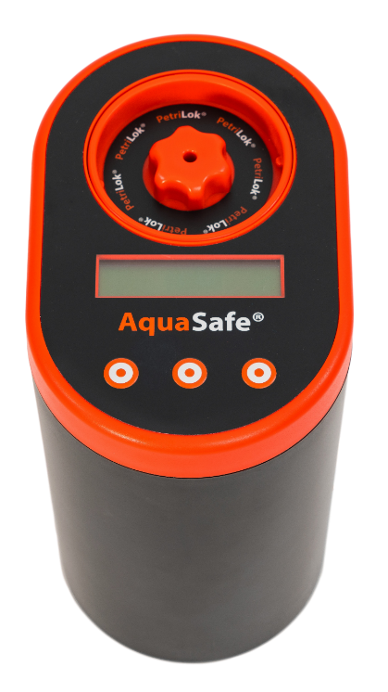

# 2.0 Incubator set-up

The incubator is integrated into the waterproof carry case with a docking station which incorporates the rechargeable battery pack and power supply for the unit. An external charger is also supplied which is connected to the port on the rear of the case.

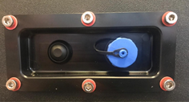

The power pack is comprised of a 12V 15.6Ah Sealed **Non-Spillable** Lead acid battery. The battery pack must be electrically isolated during transport on-board aircraft. To facilitate this, a switch has been incorporated in the carry case which isolates the power supply.

**Please note when transporting via aircraft the switch must be in the off position (depressed) and secured such that it cannot become depressed during transit (covering the recessed plate with rigid card should achieve this).**

## 2.1 Docking Station

The Incubator is mounted on a docking station built into the carry case, which incorporates the rechargeable battery pack and allows the incubator to be run from the batteries during transportation. It is also possible to use the incubator on a bench independent of the dock if desired, as long as it is connected to a 240 V AC outlet via the cables provided.

To remove the incubator from the docking station, lift the incubator vertically upwards, ensuring not twist or tilt the incubator as this could result in damage to the connectors. To place the incubator back onto the docking station, centre the incubator left to right on the docking station with the front edge against the foam, then push down into position.

## 2.2 Battery Removal

It may be desired to remove the batteries or replace them at the end of their life. To replace or remove the batteries first ensure the switch on the rear of the carry case is in the off position then remove the screw on the left side of the docking station.

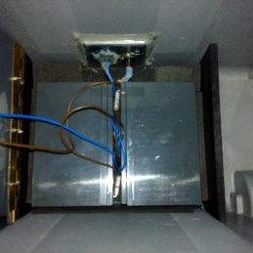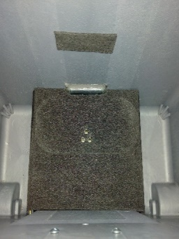

Next lift up the hinged panel from left to right which will reveal the two batteries. To remove the batteries lift each battery out carefully and disconnect the wires from the battery terminals. Replacement is the reversal of removal. Ensure that the brown wires go to the red terminals and that the blue wires go to the black terminals. Failures or damage arising due to incorrect connection of the wires will invalidate the warranty. It is also advised that batteries are only removed if absolutely necessary.

## 2.3 Battery Charging

It is recommended to charge the battery fully prior to use. To do this remove the power supply unit from the kit and connect it to the charging connection on the rear of the carry case, screwing firmly into position. Plug the other end into a 90 - 240V AC outlet, then switch on the unit via the on/off switch on the rear of the case. The indicator on the charger will illuminate red, orange or green. The states indicate battery condition as follows:

Red: discharged.

Orange: Partially charged.

Green: Fully charged.

To charge the battery from a discharged state takes approximately 4-6 hours. If desired the incubator can be used whilst the battery is being charged however the battery will charge at a lower rate.

**Note: The battery charger comes complete with an IEC C19 to UK mains lead. Replacement leads must be of the same type with a sealed plug and maximum cable length of 2 metres, and must carry the CE mark.**

## 2.4 Vehicle Power

The incubator is also supplied with a vehicle cigarette lighter cable. This cable can either be plugged into the socked on the rear of the carry case or into the incubator on the right side of the unit. Then plug the cigarette lighter plug into the cigarette lighter socket in the vehicle. 12V or 24V vehicle systems may be used. Note that the internal battery will not charge while connected to the vehicle. It is advised that the vehicle’s engine should be running for the majority of the period of time that the incubator is used to prevent discharge of the vehicle battery. Alternatively, an auxiliary battery may be used (cable available separately).

**Note: The vehicle cigarette lighter charging lead is a specialist product and as such only a genuine Trace2o® replacement should be used. Replacements are available from any Trace2o**® **approved representative.**

**No attempt should be made to charge or power the equipment other than via the approved Trace2o**® **equipment.**

## 2.5 Fuse

The docking station contains a fuse to protect the incubator in the unlikely event of a short circuit or thermal runaway. In the event of fuse failure, the fuse may be replaced, provided the cause of the fault is identified and rectified.

To replace the fuse, locate the fuse holder in the battery compartment as illustrated below:

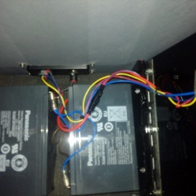

Unscrew the fuse holder and remove the fuse. Replace with the same type (only as specified in section 5.1) and screw the fuse holder back together.

# 

# 3.0 Operating instructions

## 3.1 Incubator controls

The incubator has a power connection socket on the right hand side of the unit and three switches on the top which control all functions of the incubator.

The incubator can be run from a power supply in the range 12 – 24 Volts.

All information is displayed to the user via the LCD display on the top of the unit.

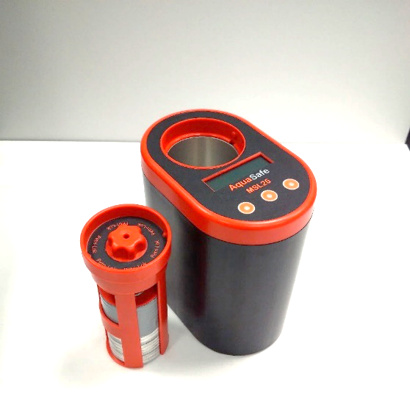

**Petri-Lok® Cassette.**

The Petri-Lok® cassette consists of a rack and a spring loaded top to hold the petri-dishes in place. To remove the cassette twist the cassette to the left and lift out. The top of the cassette is removed by pushing down on the top whilst holding the rack, twisting to the left and then removing the top. To re-fit align the arrow with either of the two slots in the top of the rack, push down and twist lock into place.

## 3.2 Getting started

Instructions for membrane filtration are covered in another section of the kit manual. **The user should familiarise themselves fully with the set-up, control and calibration of the incubator prior to carrying out tests for the first time.**

If the incubator is connected to the docking station, turn on using the switch on the rear of the carry case. If connected directly to the power supply turn on the power at the AC mains outlet.

The incubator screen will turn on.

The incubator may be in one of three operating modes on power up:

1: New run

2: Partial incubation cycle (Idle)

3: Partial incubation cycle (Run)

If the incubator is in mode 1 or 2 the screen shown in **Fig 1.0** (see page 8) will be displayed. If the incubator is in mode 3 the incubator will return to the last know state and auto start the incubation cycle from where it was before the power was removed. Mode 3 is primarily intended for unattended power failure conditions. If **Fig 1.0** is displayed and the incubator was in mode 2 then the previous incubation cycle can be restarted from where it was left by pressing restart. This will be discussed later. The screen will be displayed for 60 seconds before defaulting to the restart condition.

Pressing the right-hand switch will reset the incubator ready to set-up and start a new incubation cycle and the screen will change to the one shown in **Fig 1.1** (see page 8). Pressing the left-hand button will step through the screens as illustrated in the cyclic sequence shown in **Figures** **1.1** to **1.8.**

Each screen and options will now be discussed in further detail.

## 3.3 Menu Options

The incubator is a menu driven system. In section 3.3.1 the menu sequences will be outlined. In section 3.3.2 onwards, the detailed instructions for each screen will be described for the chamber. Once the incubator is in run mode, changes cannot be made to the settings of the chamber. To make changed to the settings or the sequence, the user will need to exit the run mode. This is to prevent accidental changes to an incubation cycle which may cause the test to fail.

### 3.3.1 Menu sequence

Once the user has selected Restart or New Run, pressing the left switch will step through the following sequence.

Select Option

Restart New Run

Fig 1.0

Fig 1.8

20.9°C 24:00

U->##° MEM 10.5v

20.9°C 24:00

->44° MEM 10.5v

20.9°C 24:00

->37° MEM 10.5v

20.9°C 24:00

OFF MEM 10.5v

20.9°C 24:00

Cal <ADJ 10.5v

20.9°C 24:00

New <SEL 10.5v

Fig 1.1

Fig 1.7

20.9°C 24:00

U->##° <ADJ 10.5v

Fig 1.2

Fig 1.6

20.9°C 24:00

Tim <ADJ 10.5v

Fig 1.3

Fig 1.5

## 3.3.2 Start Screen (Figure 1.1)

Time Remaining

Current Temperature

20.9°C 24:00

OFF MEM 10.5v

Battery Voltage

Incubator Status

Mode

This screen shows the current status of the incubator.

In the state shown the incubator is in idle mode and not running.

### 3.3.3 37°C Program (Fig 1.2)

20.9°C 24:00

->37° MEM 10.5v

This mode is the pre-programmed default 37°C incubation cycle. In this mode the incubator will run an 18-hour incubation cycle at 37 °C. The timer can be altered to any setting between 0 and 24 hours. Adjusting the incubation time is described in section 3.3.7.

Pressing and holding the middle switch for 5 seconds will start the incubation cycle and the display will change to the following:

*20.9°C 24:00

->37° RUN! 10.5v

The asterisk preceding the temperature will switch on and off indicating the status of the heater.

To stop or pause the incubation cycle press and hold the middle switch again for 5 seconds. The display will return to the one shown in Fig 1.2.

Once the chamber has reached the pre-set temperature the timer will start to countdown. If for any reason the temperature should drop, such as power failure, the timer will auto pause until the temperature is back to the pre-set temperature. It should also be noted that if there is a power failure the timer will reset back to the nearest hour. So, a reset at 17:35 would result in a reset to 17:00.

The timer displayed is a countdown timer so it will display the time left not the elapsed time. When the timer reaches 00:00 a buzzer will sound intermittently and the display will display done A where A is the chamber.

### 3.3.4 44°C Program (Fig1.3)

20.9°C 24:00

->44° MEM 10.5v

This mode is the pre-programmed default 44°C incubation cycle. In this mode the incubator will run a 24-hour incubation cycle at 44°C. The timer can be altered to any setting between 0 and 24 hours. Adjusting the incubation time is described in section 3.3.7.

Pressing and holding the middle switch for 5 seconds will start the incubation cycle and the screen will change to the following:

*20.9°C 24:00

->44° RUN! 10.5v

The asterisk preceding the temperature will switch on and off indicating the status of the heater.

To stop or pause the incubation cycle press and hold the middle switch again for 5 seconds. The display will return to the one shown in Fig 1.2.

### 3.3.5 User defined Program (Fig 1.4)

20.9°C 24:00

U->##° MEM 10.5v

This mode will run an incubation cycle at the user defined temperature for 24 hours. Adjusting the user defined temperature is described in section 3.3.8. The timer can be altered to any setting between 0 and 24 hours. Adjusting the incubation time is described in section 3.3.7. Pressing and holding the middle switch for 5 seconds will start the incubation cycle and the screen will change to the following:

*20.9°C 24:00

U->##° RUN! 10.5v

The asterisk preceding the temperature will switch on and off indicating the status of the heater. To stop or pause the incubation cycle press and hold the middle switch again for 5 seconds. The display will return to the one shown in **Fig 1.2.**

### 3.3.6 Resetting the timer (Fig 1.5)

20.9°C 24:00

New <SEL 10.5v

In this mode pressing the middle switch will display the following screen which will flash rapidly to warn the user this will reset the timer and the elapsed time data will be lost:

15:45 TIMER A

RST

The time remaining is displayed in the top left corner. This can be reset to the programmed default cycle time by pressing the middle switch. After the switch press it will jump to the screen shown in **Fig 1.1**. Should this mode be entered by mistake do not press the middle button. Turn off the incubator and then turn back on which will exit this mode and return to the menu without resetting the timer.

### 3.3.7 Incubation cycle time setting (Fig 1.6)

20.9°C 24:00

Tim <ADJ 10.5v

In this mode the default cycle time can be changed from 24 hours to anywhere between 0 and 24 hours.

Before adjusting the cycle time, reset the timer as described in section 3.3.6.

To adjust the time press the middle switch. The screen will change to:

18:00 TIMER A

- Save +

Pressing the left switch will decrease the time and pressing the right switch will increase the time. When the desired time has been set press and hold the middle switch to save the settings. The display will return to the one shown in **Fig 1.1**.

### 3.3.8 User defined temperature setting (Fig1.7)

20.9°C 24:00

U->##° <ADJ 10.5V

In this mode the user defined incubation temperature can be adjusted to a temperature between 20°C and 50°C.

To adjust the temperature, press the middle switch. The screen will change to:

##.#°C User Temp

* Save +

Use the left switch to decrease the temperature and the right switch to increase the temperature. When the desired temperature is set press and hold the middle switch to save the settings. The display will return to the one shown in **Fig 1.1**.

## 3.3.9 Calibration (Fig 1.8)

Fig 3.1

20.9°C 24:00

Cal <ADJ 10.5V

In this mode the incubator is calibrated.

To calibrate the unit the following equipment is required:

* Digital thermometer with 100mm x 4mm stainless steel probe (Included)
* Trace2o® Incubator calibration pack (Included)
* Petri-Lok® Petri-dish cassette
* 10 Aluminium Petri dishes

Assemble the cassette as follows (**Fig 3.1**):

* Place 10 empty Petri dishes into the bottom of the cassette
* Then place the calibration pack into the cassette
* Fit the spring loaded top and insert the thermometer through the hole in the top. The thermometer will protrude by approximately 30mm when fully inserted

Fit the cassette into the incubator chamber.

Set the incubator to the desired mode of operation (37/44/User) and start the incubation cycle. Wait at least 1 hour. Compare the displayed temperature on the incubator screen to that shown on the thermometer. If there is a difference > 0.2°C the calibration should be adjusted as follows:

Exit the run mode and step through the screens until the calibration screen is displayed. Press the middle switch to enter calibration mode. The following screen will be displayed:

##.#°C Calibrate

* Save +

Adjust the temperature up or down using the left and right switches until it matches the temperature displayed on the thermometer. Press the middle switch to save the settings. Step through the screens until the mode previously used for calibration is displayed and start the incubation cycle again. Allow the incubator time to adjust the temperature which could take up to 30 mins and check the calibration again. If the original temperature was significantly different to the thermometer then the calibration steps may need to be repeated two or three times.

# 4.0 Care and Maintenance

## 4.1 General

The AquaSafe® incubator is designed to require minimal maintenance if used correctly and the instructions herein are adhered to, although from time to time cleaning and basic maintenance will be required as outlined in sections 4.2 and 4.3.

If the equipment is used in a manner not specified by the manufacturer, the protection provided by the equipment may be impaired.

## 4.2 Cleaning

**Before cleaning the incubator ensure that the power supply is disconnected, the incubator is turned off and has cooled down.**

**After cleaning ensure all parts are thoroughly dried prior to operation.**

To clean the incubator outer surfaces and plastics use a cloth moistened with a mild soap solution or an alcohol impregnated cloth or wipe. **Do not** use acetone or other solvents.

The incubator is splash proof but it is not fully waterproof so it should not be left outside in wet conditions and **must not** be submersed in water.

The incubator chamber is sealed at the bottom so spills will not affect the unit but should be cleaned as soon as possible. The Aluminium chamber can be cleaned with Alcohol, soap or solvent based cleaners. **Do not** use abrasive or chlorine-based cleaners.

The Petri-Lok® rack can be steam sterilised if required but it is not recommended to steam sterilise the top.

The AquaSafe® carry case and integral docking station is waterproof when the lid is fully closed and the connector cap is fitted. When closed the case can be washed with a mild soap solution or rinsed with a hose. The case is also resistant to most solvents and acetone.

Internally the case can be cleaned with a damp cloth but water should not be allowed inside as this could result in a short circuit, causing the batteries to overheat. **If water was to penetrate the case, turn off the incubator immediately, open the docking station and disconnect the batteries**. Dry as soon as possible and ensure it is thoroughly dried before reconnecting the batteries and operating the incubator.

## 4.3 Maintenance

The wheels should be periodically cleaned. When dry add a drop of lubricating oil to the wheel axles to prevent seizing. All screws in the case are fitted with anti-vibration nuts or secured with adhesive. However, after transporting the case in a vehicle, it is suggested to check the integrity of the docking station and any screws to ensure no damage has occurred and all electrical connections are secure prior to use.

After a period of time replacement of the rechargeable lead acid batteries may be necessary. If so, these must be replaced with batteries of the same type as specified in section 5.1 and replaced as a pair. Should any fault occur please contact the Trace2o® Technical Team who will be more than happy to advise you.

# 5.0 Technical Specification

## 5.1 Docking station:

|  |  |
| --- | --- |
| **Power supply** |  |
| Input (Max) | 12-28V DC, 48W ( via supplied Power supply unit or vehicle charging lead only) |
| Output (Max) | 12-28V DC, fused 24W |
| Fuse | 2A Type T |
| **Environmental** |  |
| Operating temperature range | 15 – 50°C |
| Storage temperature | 0 – 70°C |
| **Protection** |  |
| Water ingress (Closed) | IP68 (1hr, 0.2m) |
| Buoyancy | 47Kg |
| **Batteries** | Panasonic UP-VW1245P1 Rechargeable Lead Acid Battery 12V, 7.8Ah |

## 5.2 Incubator:

|  |  |
| --- | --- |
| **User Interface** |  |
| Display | 16 x 2 LCD |
| Keypad | 3 key, tactile chemical resistant keypad |
| **Power supply** |  |
| Input (Max) | 12-28V DC, 24W ( via supplied Power supply unit vehicle charging lead or docking station only) |
| **Environmental** |  |
| Operating temperature range | 0 – 50°C |
| Storage temperature | 0 – 70°C |
| **Protection** |  |
| Water ingress (Closed) | IP68 (1hr, 0.2m) |
| Buoyancy | 47Kg |

# 6.0 Guarantee and Assistance

Trace2o® hope that the AquaSafe® incubator will give many years of trouble free operation, but in the event of a technical problem occurring the AquaSafe® incubator is covered by Trace2o® Ltd’s standard Guarantee terms and conditions available via email or via download from [www.trace2o.com](http://www.trace2o.com). In the event that any technical assistance is required, the Trace2o® Customer Service department will be happy to assist. Contact details as follows:

Trace2o Ltd

The Technology Centre

Station Road

Thatcham

Berkshire

RG19 4HZ

UK

T: 01635 866772

E: [Technical@Trace2o.com](mailto:Technical@Trace2o.com)

**Section 4**

**AquaSafe**

**Membrane Filtration**

**Instruction Manual**

# Contents

Contents 31

SECTION 1: ASSEMBLY OF FILTRATION APPARATUS 32

SECTION 2: PREPARING BACTERIOLOGICAL MEDIA IN A LABORATORY FACILITY 34

SECTION 3: PREPARING BACTERIOLOGICAL MEDIA IN THE FIELD 35

SECTION 4: SAMPLING 36

SECTION 5: USE OF BACTERIOLOGICAL MEDIA 38

SECTION 6: ASEPTIC PROCEDURES 39

SECTION 7: PROCESSING SAMPLES FOR COLIFORM ANALYSIS 41

SECTION 8: COUNTING COLIFORMS AND RECORDING THE RESULT 44

SECTION 9: SELECTING THE OPTIMUM VOLUMES FOR MEMBRANE FILTRATION 45

# SECTION 1: ASSEMBLY OF FILTRATION APPARATUS

2

3

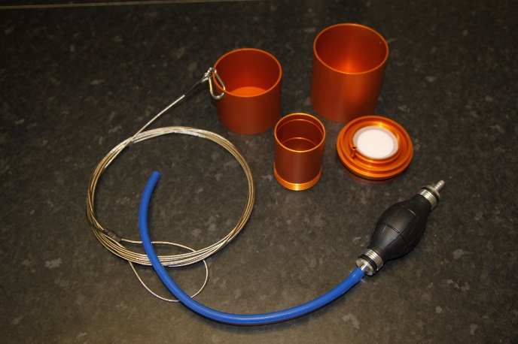

5

4

1

Hand Vacuum Pump

Filtrate Flask / Waste Beaker

Sampling Cup and cable

Graduated Aluminium Funnel

Membrane Support & Holder

Sealing Gaskets

Glass Sintered Disc (Membrane Support)

Place one gasket within the recess of the support holder and press into place. Place the sintered disc, smooth side facing upwards, into the centre of the gasket. Push the other two gaskets into place around the sintered support disc.

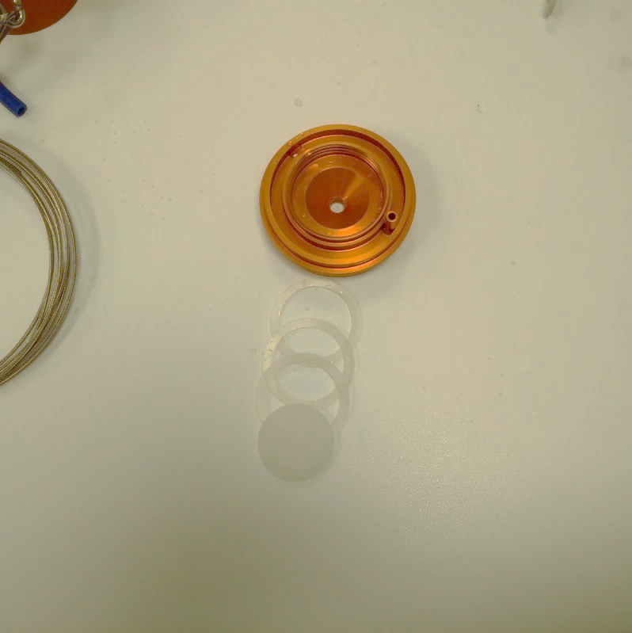

The graduated funnel screws clockwise into position. Do not over-tighten the funnel.

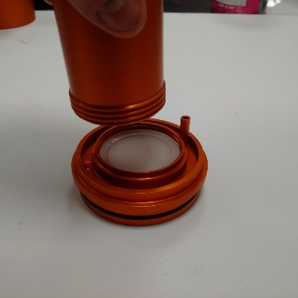

# SECTION 2: PREPARING BACTERIOLOGICAL MEDIA IN A LABORATORY FACILITY

**Membrane Lauryl Sulfate Broth:** For 50 tests, dissolve 7.62g of Membrane Lauryl Sulfate Broth (one sachet) in 100mL deionised water.

The broth is supplied in a pre-weighed sterile sachet, with indicating silica gel that will turn from orange to green, to indicate moisture penetration.

Tear open the sachet and remove the silica gel with the forceps. If the silica gel is green, discard the sachet without using.

Pour the entire contents of the sachet into 100mL of deionised water.

Gently heat the mixture to ensure that the powder is fully dissolved, but do not boil.

After ensuring that the 125mL plastic bottles provided contain no residues of previous MLSB or cleansing agent, pour the prepared medium carefully into the bottles.

Replace bottle lids but leave them slightly loose - do not fully tighten.

Sterilise in an autoclave at 121°C for 10 minutes, or place bottles in a pressure cooker and maintain in steam at pressure for 15 minutes. Remove the bottles, allow them to cool to room temperature, fully tighten the tops and then store in a cool, dark place.

When the media has cooled to room temperature, pour sufficient MLSB (2mL) onto each membrane pad to saturate the pad.

When the pad is fully saturated, decant any excess MLSB as waste

**Media Ampoules:** Media Ampoules are pre-sterilised ampoules containing 2 mL of dissolved media. They have the advantage of convenience and of always being sterile. These ampoules are available for Faecal Coliform Counts (pack of 50) and Total Coliform Counts (pack of 50). Simply unscrew the cap, pour the media onto the pad and discard the empty ampoule.

# SECTION 3: PREPARING BACTERIOLOGICAL MEDIA IN THE FIELD

**Membrane Lauryl Sulfate Broth:** For 50 tests, dissolve 7.62g of Membrane Lauryl Sulfate Broth (one sachet) in 100mL deionised water.

The broth is supplied in a pre-weighed sterile sachet, with indicating silica gel that will turn from orange to green, to indicate moisture penetration.

Tear open the sachet and remove the silica gel with the forceps. If the silica gel is green, discard the sachet without using.

Open a bottle of ‘Sterilised water for broth preparation’ and carefully pour the entire contents of the sachet into the bottle.

Replace the bottle lid tightly, and vigorously shake the mixture to ensure that the powder is fully dissolved.

Use the syringe provided to dispense 2mL of prepared broth onto each membrane pad.

# 

# SECTION 4: SAMPLING

**Rivers and streams**

Take the sample as near as possible to the fastest flow – this will typically be found towards the centre of the body of water. Avoid taking samples from too close to the bank, where the water may be still and unrepresentative.

Care must be taken not to introduce floating debris, or solid matter from the banks of the water course, into the water sample. Therefore, it may be preferable to attach the sampling cable to the sterilised sampling cup and take the sample from a bridge or other overhanging location. Alternatively, the cup may be cast out into the water from the edge and pulled slowly and carefully back towards the operator.

**Chlorinated drinking water**

When storing samples of water in bottles for analysis at a later date, from sources that contain residual chlorine, such as treated drinking water, the bottled sample must be dechlorinated, i.e. the residual chlorine has to be removed to prevent further chlorination (and killing of bacteria) whilst in transit. To dechlorinate the water, the supplied sample collection bottles contain dechlorination tablets. N.B. If the sample is analysed immediately on-site, then it is not necessary to dechlorinate the water.

**Dechlorination**

The dechlorination tablets are pre-placed inside each sample collection bottle. Simply pull off the sterile seal, pour the sample from the sampling cup into the sample collection bottle, seal and shake thoroughly to ensure thorough dissolving of the tablet. The tablet will have no adverse effect on unchlorinated water.

**Tap Samples**

Turn on tap and allow water to flow for about 2 minutes, to flush the sampling pipeline.

Take an initial sample and carry out any appropriate on-site physical & chemical tests e.g. Residual chlorine, turbidity, temperature & pH. Take any other required physical and chemical samples. Then disinfect the tap, which can be carried out in the two following ways:

**Chemical Disinfection of Tap**

Turn off the tap.

Squirt the inside of the tap with concentrated sodium hypochlorite solution (e.g. bleach), with a wash bottle.

Leave for 3 minutes to disinfect fully.

Flush the tap until all the bleach has been washed off – this can be verified by taking further residual chlorine tests.

Fill the prepared bacteriological sampling bottle (leave a slight air gap at the top) and seal the lid tightly.

**Heat Disinfection of Tap**

This method is applicable for metal taps, but not for any plastic taps or taps with non-removable anti-splash devices.

Turn off the tap fully, and flame the closed tap with a small Propane or Butane burner; cease flaming if/when any steam issues from the tap.

Flush the tap until the water cools to its original temperature.

Fill the prepared bacteriological sampling bottle (leave a slight air gap at the top) and seal the lid tightly.

**Dip Sample**

Sterilise the sampling cup by igniting 1ml of methanol/alcohol in the cup.

Allow to cool.

Rinse the alcohol from the cup with water from the sample source.

Immerse the cup into the water source to obtain the sample.

Pour into the prepared bacteriological sampling bottle (leave a slight air gap at the top) and seal the lid tightly.

# 

# SECTION 5: USE OF BACTERIOLOGICAL MEDIA

If stored correctly, the dissolved media should remain stable for 6-8 weeks. However, if there are any signs of contamination e.g. yellowing, cloudiness etc., discard.

Ideally, to reduce the possibility of contamination, use one bottle of media only for a 24 hour period, and use a fresh bottle on each subsequent day. However, if this is not possible, then the bottle must be resealed immediately after use. The media may be re-sterilised if required by boiling in a water bath for 15 minutes.

Clean empty media bottles thoroughly before re-use. Any residues should be washed out with hot water; cleaned with a little detergent (a small brush can be used if required); rinsed several times in clean water, dried and stored in a clean environment, with the lids lightly attached.

The MLSB solution may be applied to the pads up to 6 hours before sampling, if the pads are subsequently stored in a cool environment. This procedure can reduce the potential for contamination with excessive operations in the field.

If the MLSB powder is stored in the original sachets in dry, cool conditions it should have a shelf life of up to 5 years from the date of manufacture.

# 

# SECTION 6: ASEPTIC PROCEDURES

Aseptic procedures are of paramount importance during microbiological analysis, and extra care must be taken when outside the central laboratory, i.e. in the field. **Everything must be kept clean and sterile, particularly on the following surfa**ces:

Inner surface of the sampling cup

Inner surface of the graduated filter funnel

Filter membrane and absorbent pads

Upper surface of the sintered membrane support disc

Inside of the petri dishes

Support pad dispenser arm, and forceps

Before every use, rinse the filtration unit and sampling cup in clean water,   
and dry by using clean tissue paper.

Pour approx. 1 mL of methanol into the sampling cup and swirl. (The methanol can be stored in the plastic bottles provided).

Place the sample cup in a normal upright position, away from any flammable substances.

Using a suitable means (cigarette lighter), ignite the methanol – **TAKE CARE AROUND THE NAKED FLAME.**

Allow the methanol to burn for a few seconds.

Whilst the methanol is still burning, invert the filtration unit and carefully place inside the sample cup. Wait for at least 20 minutes to ensure that the sample cup and filtration unit are sterile. Methanol burns anaerobically to form formaldehyde gas, which reaches all areas of the filtration apparatus and ensures a thorough sterilisation.

Pour any residual methanol solution away.

The above sterilisation procedures should be carried out immediately before sampling, and after the filtration of each sample. Reusable aluminium petri dishes must be sterilized, either by immersing in boiling water, or flaming with methanol prior to use. After sterilisation, ensure that the dishes are allowed to dry thoroughly before use. Other methods of sterilisation can be employed, including autoclaving, or placing the aluminium dishes in a conventional oven at 300°C for 30 minutes. Once sterile, the petri dishes should be handled carefully to prevent subsequent recontamination.

Pads are supplied sterile, in cartridges of 100. A sterile pad dispenser is supplied for depositing the pads into the petri-dishes. It is preferable to dispense pads at the central laboratory, prior to going to the sampling point; in this way, the dispenser may be kept attached to a pad cartridge and remain clean and sterile. If it is necessary to dispense pads in the field, great care must be taken not to contaminate either the pad dispenser or the cartridge. As soon as a cartridge is finished, a new one should be attached to the dispenser. Do not leave the dispenser unattached for any length of time. If no pad dispenser is available use sterilised forceps. **Before** handling a membrane filter with the forceps, the forceps should be flame-sterilised thusly: hold the forceps tips in a flame for at least 5 seconds, and allow to cool before handling the membrane.

# 

# SECTION 7: PROCESSING SAMPLES FOR COLIFORM ANALYSIS

All samples must be incubated within 6 hours of sampling.

Dispense a sterile absorbent pad into a sterile petri dish, and saturate the pad with prepared broth

Loosen the graduated filter funnel, and remove from the base support.

Sterilise the forceps and allow to cool. Using these forceps, place a sterile membrane onto the glass membrane support, grid side up. If the membrane tears or becomes contaminated, discard it and use a new one.

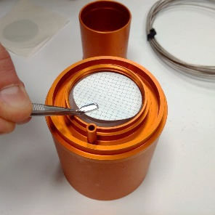

Lock the membrane in place by screwing the filter funnel down into position.

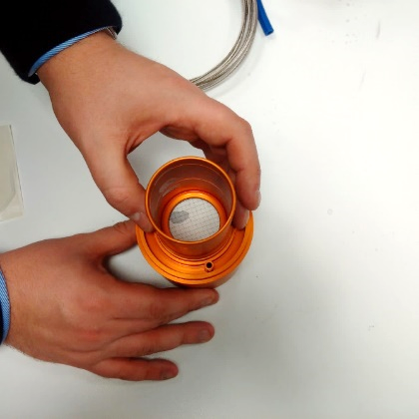

Pour the water sample into the filter funnel up to the 100 ml graduation.

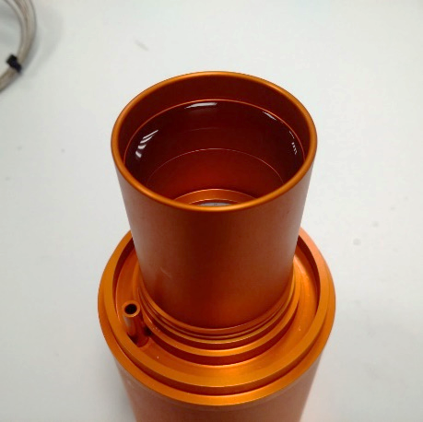

Connect the hand vacuum pump to the filtration unit base (ensuring the arrow is orientated to the direction of desired air flow) and pump in a controlled fashion to suck the water sample through the membrane.

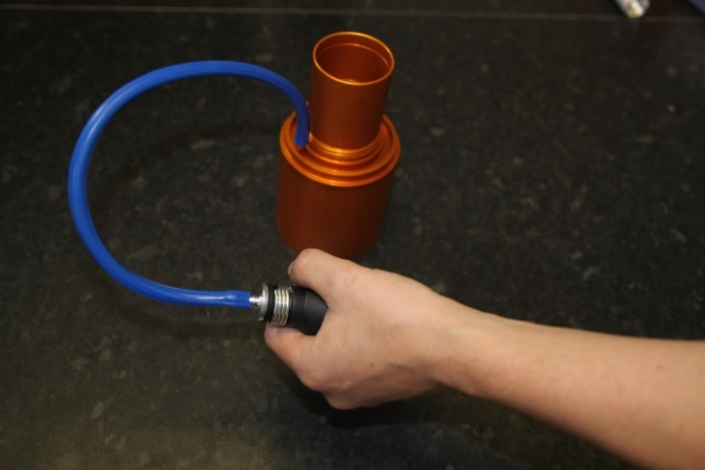



When all the water has been filtered, release the vacuum pump and use the sterile forceps to take the membrane from the filtration unit.

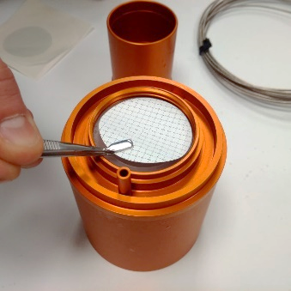

Place the membrane on top of the pad, which has been previously saturated with the MLSB media.

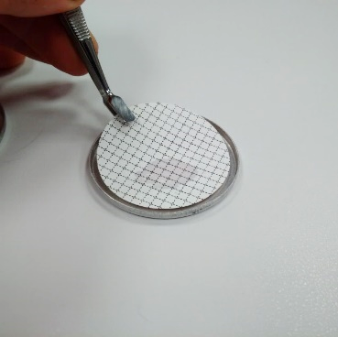

Replace the petri-dish lid and mark the petri dish. A suitable system should be adopted to record the petri dish mark, associated with the sample number, place, date, time, etc.

Place the petri-dish into the rack. Repeat the process for all the samples and then place the filled rack into the incubator.

It is important to note that when the last sample has been processed, a resuscitation period of at least one hour (but not more than four hours) must be observed before incubating. This allows any physiologically stressed coliforms to recover before culturing.

To incubate faecal (thermotolerant) coliforms, temperature of 44.5°C should be used. For total coliform analysis, a temperature of 35°C is appropriate.

# SECTION 8: COUNTING COLIFORMS AND RECORDING THE RESULT

Note the temperature that the incubator has been set for.

Following incubation, switch off the power and remove the petri dishes from the incubator.

Place the petri dishes on a flat, level surface.

Remove the lids and count all the yellow colonies, irrespective of size. Use the eye glass, if necessary. Count the colonies within a few minutes of removing from the incubator, as the colours are liable to change on cooling and standing. Ignore those colonies that are not yellow e.g. pink & transparent colonies.

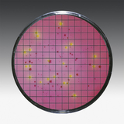

Once the number of yellow colonies has been determined, and assuming that 100 mL of sample was filtered, this number of colonies equals the number of coliforms per 100 mL. Where samples were incubated at 35°C, the count is of Total Coliforms, whilst for those incubated at 44.5°C, the count is for faecal (Thermotolerant) coliforms.

Record the results using the record sheets (if provided in the kit).

# 

# SECTION 9: SELECTING THE OPTIMUM VOLUMES FOR MEMBRANE FILTRATION

The optimum volume of sample is that which will allow the most accurate quantification of bacterial colonies. This is achieved when the number of faecal (thermotolerant) coliform colonies on the membrane following incubation is between 20 and 200 colonies. If there are fewer than 10 colonies, then there exists the possibility of statistical error. Numbers greater than 200 colonies are difficult to count with the naked eye.

Potable Waters

The number of faecal coliform bacterial colonies in treated water samples should ideally be zero. Thus, the preferred sample volume is 100 mL, and a count of zero faecal coliform bacteria per 100 mL is indicative of a microbiologically safe water supply. If the count exceeds 1 faecal coliform per 100 mL, contamination is indicated. If the count exceeds 10 faecal coliforms per 100 mL, action is urgently required.

Raw Waters

For source waters and partially treated waters, including those which are ground water derived, it can be useful to adjust the sample volume in order to obtain faecal coliform counts in the optimum range 10-200. It may also be useful to process more than one quantity on the first occasion a particular water source is sampled. In such cases it is not necessary to re-sterilise the filtration equipment between different quantities of the same sample, provided that the smaller volume is processed first. Typical volumes which may be appropriate for various water types are shown in the following table. They are only guidelines; there is no substitute for experience of a given source.

|  |  |  |  |
| --- | --- | --- | --- |
|  | APPROPRIATE VOLUME (mL) | | |
| SOURCE OF SAMPLE | 100 | 50 | 10 |
| Lakes, Reservoirs, & Rivers & other surface sources | * | ** | *** |
| Wells, boreholes, other protected water sources | * | ** | * |
| Water treatment plant partially treated | ** | ** | * |
| Water treatment plant fully treated | *** |  |  |
| Distribution system | *** |  |  |

**Section 5**

**AquaSafe**

**Turbidity Tube**

**Instruction Manual**

# SECTION 1: ASSEMBLY OF TURBIDITY TUBE

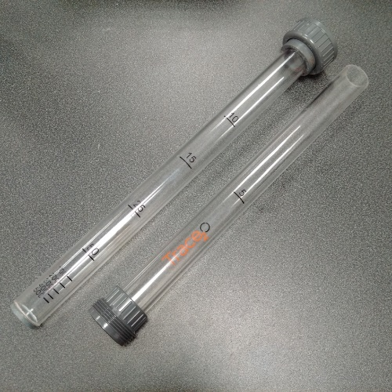

Carefully remove the two halves of the turbidity tube from their position, in the foam recess at the front of the AquaSafe Kit.

Align the two halves of the turbidity tube so that the graduations are easily visible, then push together the grey bolting mechanism and screw together using the grey waterproof connector.

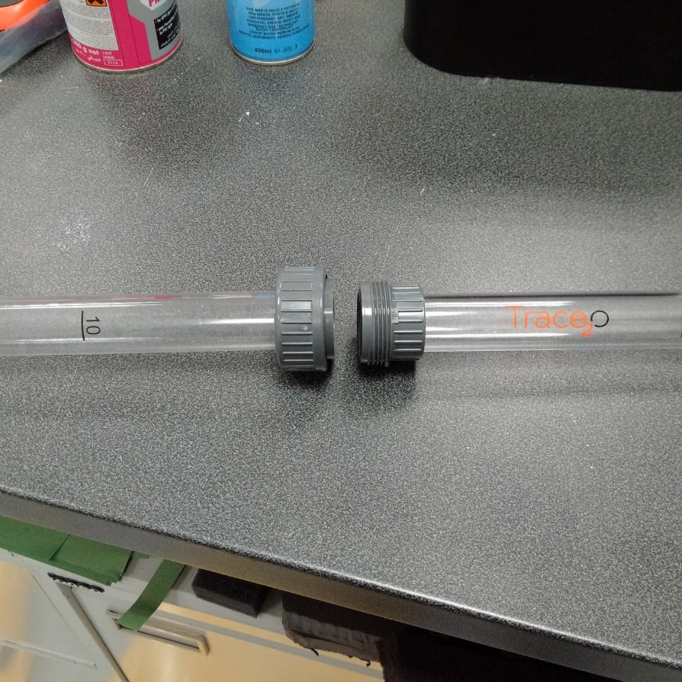

# SECTION 2: ANALYSIS

Good illumination is essential for accurate use of the turbidity tube.

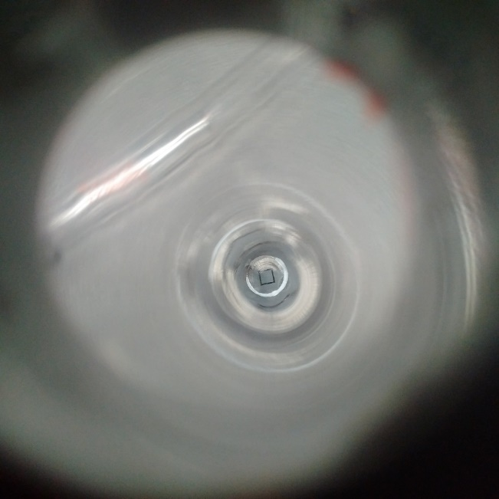

Look through the open end of the tube, at the black square on the base of the tube. This is the Trace2o Secchi marker.

Hold the tube vertically, and slowly pour the water sample to be analysed into the tube, until the moment that the Secchi marker is no longer visible from the top of the tube.

Alternatively, fill the tube, then slowly pour small portions away, until the moment that the Secchi marker becomes visible from the top of the tube.

Hold the tube vertically, and identify the water level.

The turbidity value is that marked next to the graduation line nearest the water level.

The graduations follow a logarithmic scale, with the most critical values marked on the tube, and therefore the turbidity tube can only ever be an estimate for the turbidity of the water sample.

**Note: bubbles may cause false readings.**

The turbidity tube is calibrated to a person with normal (6/6) visual acuity.

**Section 6**

**AquaSafe**

**Block Tester**

**Instruction Manual for WSL Range**

# SECTION 1: GETTING TO KNOW YOUR BLOCK TESTER

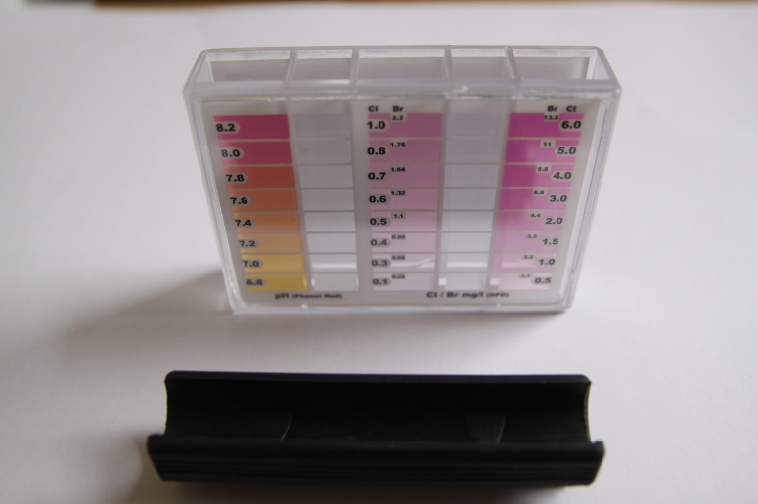

There are five chambers – three behind coloured overlays, and two clear. The two clear chambers are those into which tablets should be added.

The chambers are referred to by a number from 1-5, as shown in the above image.

# SECTION 2: PREPARATION:

Remove the black rubber cap and immerse the entire block tester in the water sample to Grip the pool tester by the sides – avoid placing fingers inside the chambers.

# SECTION 3: pH (PHENOL RED) TABLET

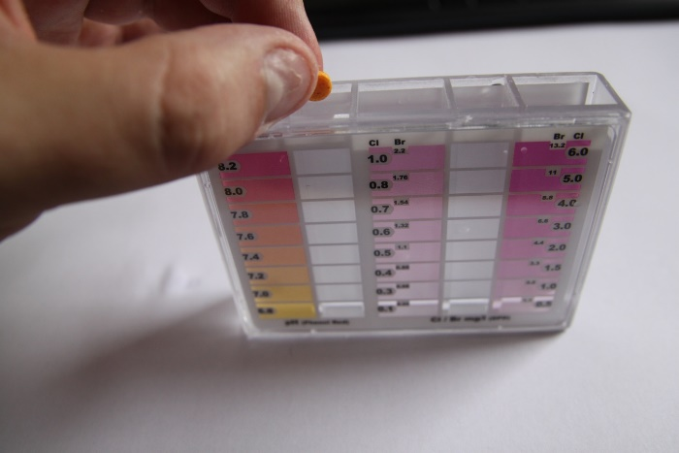

Take 1 x Phenol Red tablet directly from the foil, and add to chamber **2**.

**SECTION 4: FREE CHLORINE (DPD1) TABLET**

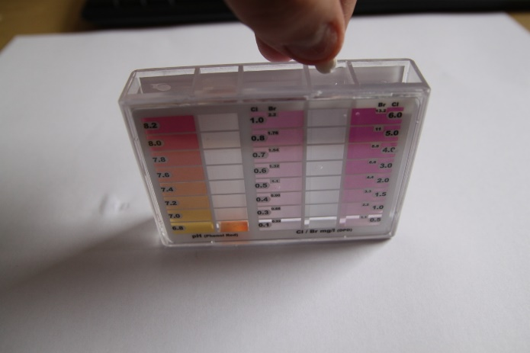

Take 1 x DPD1 tablet directly from the foil, and add to chamber **4**.

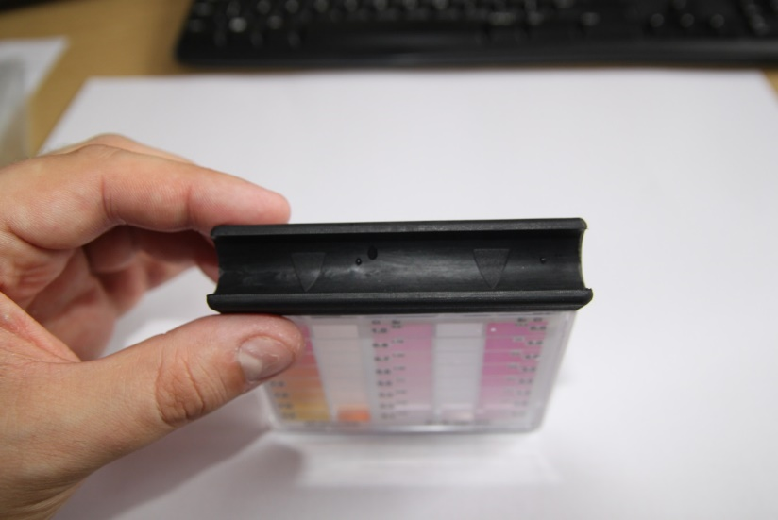

Recap the block tester firmly, ensuring that the arrows on the black rubber cap are pointing towards the coloured overlays.

Shake vigorously, and hold up to the light to read the result.

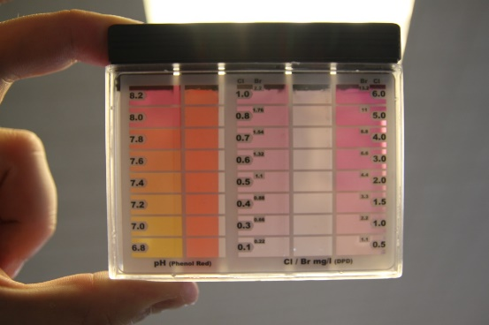

**pH** - Choose the closest colour match between the colour of the test sample in chamber **2**, and the coloured overlay on chamber **1**. Record the result.

**Free Chlorine** – Choose the closest colour match between the colour of the test sample in chamber **4**, and the coloured overlays on chambers **3** and **5**. Record the result.

Notes:

pH values below 6.5 always produce a yellow colouration.

pH values above 8.4 always produce a red colouration.

Water samples with low total alkalinity may give incorrect results.

Turbid samples should be filtered prior to analysis for best colour match.

**SECTION 5: TOTAL CHLORINE (DPD3) TABLET**

Remove lid from block tester and add one **DPD No. 3 Tablet** to chamber **4**.

Replace lid, shake to mix, and wait two minutes for colour to develop.

Shake vigorously, and hold up to the light to read the result.

**Total Chlorine** – Choose the closest colour match between the colour of the test sample in chamber **4**, and the coloured overlays on chambers **3** and **5**. Record the result.

Combined Chlorine mg/L (ppm) = Total Chlorine mg/L – Free Chlorine mg/L

Notes:

Take care not to over shake or aerate the sample.

Store the reagents in a cool, dry place.

Turbid samples should be filtered prior to analysis for best colour match.