Tracelogger®
User Manual

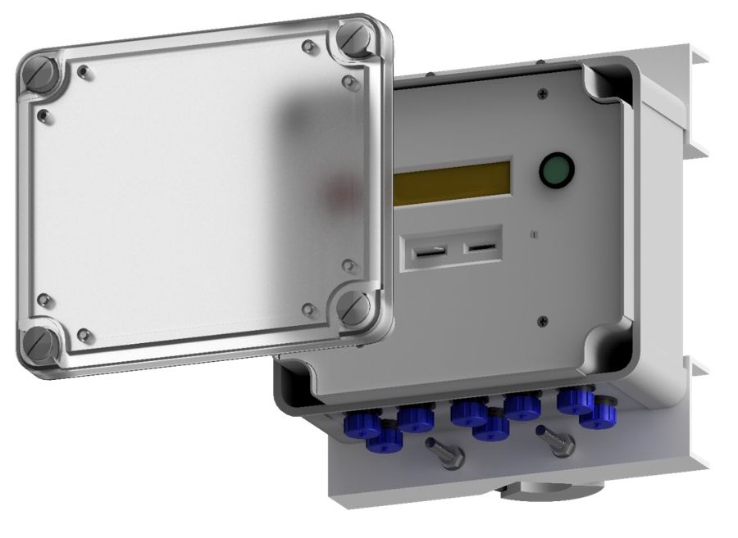

PUBLISHED BY
Trace2o
Wagtech Court
Station Road
Thatcham
Berkshire RG19 4HZ
United Kingdom

Visit our internet pages at:
www.wagtechprojects.com
www.trace2o.com

©Trace2o 2020
No part of this manual may be reproduced without any form or by any means, electronic or mechanical (including photocopying), nor may its contents be communicated to a third party without prior written permission of the copyright holder.
The contents are subject to change without prior notice.

Please observe that this manual does not create any legally binding obligation for Trace2o towards the customer or end user. All legally binding commitments and agreements are included exclusively in the applicable supply contract or Conditions of Sale.

Table of Contents
1. General Information 4
About this Manual 4
Version Information 4
2. Introduction 5
3. Technical specification 5
4. Recommended Terminal interface software 6
5. Configuring the logger 6
WMO Reports (SYNOP and METAR) 12
6. Deploying the logger 13
Connect logger to a PC 13
Configure the logger 15
Set date-time 15
Checking the system 15
7. Data collection 16
Appendix A - Frequently ask questions and Troubleshooting 17
1. FTDI driver auto installation 17
2. System Troubleshooting 17
3. Bootloader firmware upgrading 18

General Information

About this Manual
This manual is intended as a general guide for installing, wiring and using a Tracelogger data logger. The information contained in this manual may not cover all aspects of Tracelogger’s applications. Please refer to associated equipment manuals or consult papers and technical notes on the Trace2o website.

Version Information
Table 1 - Document Revisions
TRACE2O Document Number: | Description:
UM-155-607-Tracelogger User Manual | Version 1.0 – 14th January 2020 - DRAFT
UM-155-607-Tracelogger User Manual | Version 2.0 – 14th January 2020 – First Release
UM-155-607-Tracelogger User Manual | Version 3.20 – 26th March 2020 – (version number matched firmware version)
UM-155-607-Tracelogger User Manual | Version 4.00 – 7th July 2020
UM-155-607-Tracelogger User Manual | Version 4.01 – 31st July 2020

Introduction

The Trace2o Tracelogger provides an efficient and economical method of remotely logging hydro-met sensors. It can sample, process, send and record data from several types of sensors. Basic analogue and digital outputs to certain SDI-12 (serial) devices.
The Tracelogger is not a standard logger – it has been designed as a convenient way of getting real-time data fast from a remote location to either an HTTP or FTP server. The Tracelogger also saves data to an internal SD-Card for local or back up use.
All the configurations of the Tracelogger logger are taken care of from text files on the SD Card. This allow easy changes in the field without the need of expensive and complicated equipment or dedicated software.

Technical specification

Operating Range | -40° to 60°C (-40° to 140°F)
Sampling Interval | Individually set for each channel/sensor: 3secs – 24 hr
Reporting Interval (HTTP or FTP) | 1 minute up to 24 hours at set intervals
Memory | Internal 2Gb or 4Gb SD Card provided (SD Card limit of 4Gb)
No. of Channels | Ch1: Fixed SDI-12 channel (for certain approved devices)  (Note: can log 10 fields of SDI12 data into Ch11 to 20)  Ch2: Reserved for internal use  Ch3 to 10: Eight mixed use (analogue or digital) channels.  (Note: Channels 8, 9 and 10 can measure high frequency pulses).  Ch11: Dedicated battery channel  Note: certain sensors will need to use one analogue channel for measuring the reference voltage for more accurate measurements. i.e. Wind Direction.
Time Accuracy | ±8 seconds per month in 0° to 40°C (32°F to 104°F) range;  ±30 seconds per month in -40° to 60°C (-40° to 140°F) range
Power Supply | 12V DC
Internal Modem | Quectel UC20
Size | 180mm x 200mm x 90mm
Weight | TBC
Environmental Rating | IP65

Recommended Terminal interface software

The Tracelogger does not use a dedicated interface software for configuration and set-up. This is all done through free and readily available Terminal software interfaces and loaded configurations from the SD Card.
We recommend the following software depending on your operating system:
Windows - https://www.putty.org/
Unix - https://www.putty.org/
Android – Serial USB Terminal (https://play.google.com/store/apps/details?id=de.kai_morich.serial_usb_terminal&hl=en)

These are the settings for the Terminal software:
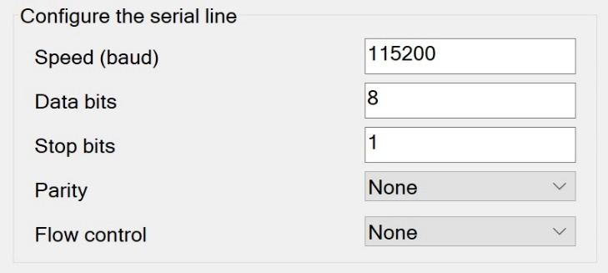
Figure 1 - Terminal software settings

Configuring the logger

To configure the Tracelogger, we use simple to use text files that are contained on the Tracelogger SD Card in the following folder “CfgV401”. Note: The folder name must match the current version number (Currently V4.01).
In this folder you will find the following text files:
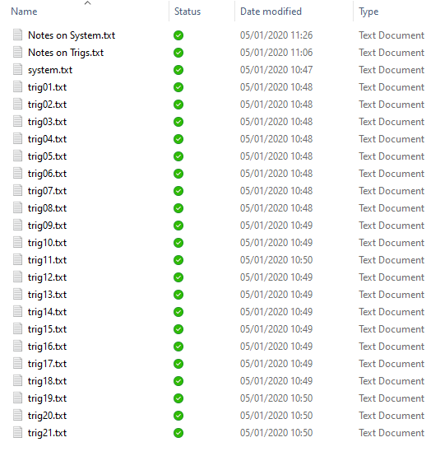
Figure 2 - Contents of Configs folder on SD Card

The main system settings are configured by the contents of System.txt and each individual channel (or as they are called on the Tracelogger, Triggers) are set up by their individual text files trig01.txt to trig21.txt
First, we will look at the contents of the System.txt file.
The system file is formatted in Json format (JavaScript Object Notation) and always starts with a “{“ and ends with a “}”. In the file we have simple pairings. The first item is the “description” and the next item is the “value” followed by a comma. For example: A Tracelogger with a unitID of Station01 and a customer identification of MetService would start as follows:
{
“unitID”:”Station01”,
“customer”:”MetService”,
…. And so no…
}
The final item – “report_count” does not end with a comma. This is important so the logger can read the file.
The following is a table showing each System Setting.
Descriptor | Value
config_name | The name of this configuration file (max 32 Characters),
unitID | The Unit ID of this device (max 32 Characters)
customer | The customer or username of this device (max 64 Characters)
synopID | The optional synopID for WMO reports (max 5 Characters)
country | The 2-digit Country Code of the station (max 2 Characters)
altitude | The station altitude in metres (used for MSL - Pressure estimation) 0 = Default
sim_apn | The SIM Card APN address - Please contact your SIM card provider for information (max 32 Characters)
simUname | The SIM Card Username - Please contact your SIM card provider for information (max 16 Characters)
simPassword | The SIM Card Password - Please contact your SIM card provider for information (max 16 Characters)
simAuthType | The SIM Card Authentication type (0=None, 1=PAP, 2=CHAP) - Please contact your SIM card provider for information
webProtocol | The Web Protocol use for transferring data reports (0=None, 1=HTTP, 2=FTP, 3=Dual FTP, 4=Split FTP) Option 3 is all reports to both FTP servers. Option 4 is CSV(FTP1) and WMO reports (FTP2)
webMsgType | The Web Message Type used for ther reports (0=None, 1=STD, 2=CSV, 3=JSON)
webREPORT | Do you want to send out a METAR or SYNOP report every hour (0 = No, 1 = METAR, 2=SYNOP, 3=BOTH) - Note Only valid for FTP. Also UnitID can only be 4-digits
webMETARext | The file extension name for the METAR report i.e. "TXT" Note Max 3 digits
webSYNOPext | The file extension name for the SYNOP report i.e. "TXT" Note Max 3 digits
webSYNOP_MsgNo | The SYNOP Report message number for the report header. i.e. 40
http_url | The HTTP URL Address if HTTP is used (max 64 Characters)
http_post | The HTTP full POST URL address (max 128 Characters)
ftp_url | The FTP URL Address if FTP is used (max 255 Characters)
ftp_port | The FTP Port used - Default 21
ftp_uname | The FTP Username (max 32 Characters)
ftp_pword | The FTP Password (max 32 Characters)
ftp_file_type | FTP file type (0=Ascii, 1=Binary) - Default = 1
ftp_ssl | FTP SSL (0=FTP, 1=FTPS) - Default = 0
ftp_transmode | FTP Transmit mode (0=Active, 1=Passive) - Default = 1
ftp_unitID_folder_flag | RESERVED - NOT YET USED - Default = 0
ftp_folder | RESERVED - NOT YET USED - Default = "/",
ftp2_url | The FTP2 URL Address if FTP2 is used (max 255 Characters)
ftp2_port | The FTP2 Port used - Default 21
ftp2_uname | The FTP2 Username (max 32 Characters)
ftp2_pword | The FTP2 Password (max 32 Characters)
ftp2_file_type | FTP2 file type (0=Ascii, 1=Binary) - Default = 1
ftp2_ssl | FTP2 SSL (0=FTP, 1=FTPS) - Default = 0
ftp2_transmode | FTP2 Transmit mode (0=Active, 1=Passive) - Default = 1
ftp2_unitID_folder_flag | RESERVED - NOT YET USED - Default = 0
ftp2_folder | RESERVED - NOT YET USED - Default = "/",
ntp_time_sync | Is a NTP Server to be used for time sync (0=No, 1=Yes)
ntp_server | Address of the NTP time server to be used (i.e. time.windows.com)
ntp_port | Port of the time server (i.e. 123)
ntp_timezone | The hour adjustment for the NTP sync time if needed. i.e. 0=None, 2=Add 2 hours, -3= Subtracted 3 hours, etc
report_period | The reporting period from 0 to 14 for transmitting the data report (See below)
report_count | The number of report_periods in a report. i.e. if report_period is 10_MIN and report_count is 6... You will receive a report every hour consisting of 10min values

Report period value is a number between 0 and 14 and represents:
Value | Report Period Result
0 | 1 Second
1 | 3 Seconds
2 | 10 Seconds
3 | 30 Seconds
4 | 1 Minute
5 | 2 Minute
6 | 5 Minute
7 | 10 Minute
8 | 15 Minute
9 | 30 Minute
10 | 1 Hour
11 | 3 Hour
12 | 6 Hour
13 | 12 Hour
14 | Daily

Note: For a Tracelogger fitted with a GPRS/GSM Modem device the (report period x report count) should not be less than 2 minutes to allow for transmission times.
Next, we will look at the contents of the trigxx.txt file. The xx in the filename represents the channel number for that sensor trigger channel. Channel 1 can be used as a SDI-12 channel. Channel 2 is reserved for internal use. Channels 3 to 10 can be user configured as analogue or digital with channels 8, 9 and 10 capable of fast pulse counting. If a Voltage Reference channel is needed, we usually use channel 7 (i.e. for mechanical wind direction). Channel 11 is a dedicated (battery) voltage channel and channels 12 to 21 are reserved for SDI-12 (virtual) data allocation. i.e. If you are using an SDI-12 combined weather sensor you can store the separated data in these channels. They do not have a physical connection.
{
"channel": This is the channel no from 1 to 21
"type": This is the channel Type from 0 to 12
"name": This is the name of the sensor or measurement (12 chars max)
"units": This is the units of the measurement
"threshold": NOT USED - RESERVED FOR FUTURE USE
"hysteresis": NOT USED - RESERVED FOR FUTURE USE
"periodType": This is the sampling period type from 0 to 4 (see below)
"period": This is the value of the above period i.e. Seconds, Minutes value
"multiplier": This is the multiplier to be applied to the reading - Default 1
"offset": This is the offset to be applied to the reading - Default 0
"VRefAdjust": This is 0 or 1. 0 = No Voltage reference adjustment 1 = Use Voltage Reference adjustment (i.e. Baro)
"VectorAve": This is 0 or 1. 0 = No Vector Averaging 1 = Use Vector Averaging (i.e. Wind Direction)
"TotalOnly": NOT USED - RESERVED FOR FUTURE USE
"reportCode": This gives the channel markers for measurements used in WMO reports. i.e. 0=None, 1=WindSpd, 2=WindDir, 3=AirTemp, 4=RH, 5=BaroPress, 6=Rainfall
}
The format is the same at System.txt file. The following table explains each descriptor.
Descriptor | Value
channel | This is the channel no from 1 to 21
type | This is the channel Type from 0 to 13 (see below)
name | This is the name of the sensor or measurement (12 chars max)
units | This is the units of the measurement (5 char max)
threshold | NOT USED - RESERVED FOR FUTURE USE
hysteresis | NOT USED - RESERVED FOR FUTURE USE
periodType | This is the sampling period type from 0 to 4 (see below)
period | This is the value of the above period i.e. Seconds, Minutes value
multiplier | This is the multiplier to be applied to the reading - Default 1
offset | This is the offset to be applied to the reading - Default 0
VRefAdjust | This is 0 or 1. 0 = No Voltage reference adjustment 1 = Use Voltage Reference adjustment (i.e. Baro)
VectorAve | This is 0 or 1. 0 = No Vector Averaging 1 = Use Vector Averaging (i.e. Wind Direction)
TotalOnly | NOT USED - RESERVED FOR FUTURE USE
reportCode | This gives the channel markers for measurements used in WMO reports (SYNOP and METAR). i.e. 0=None, 1=WindSpd, 2=WindDir, 3=AirTemp, 4=RH, 5=BaroPress, 6=Rainfall
type (channel):
Value | Measurement Selection
0 | None
1 | Digital Transition (Low to High)
2 | Digital Transition (High to Low)
3 | Digital Period
4 | Analogue Transition (Low to High)
5 | Analogue Transition (High to Low)
6 | Analogue Period
7 | Pulse Event
8 | Pulse Period
9 | Pulse Total
10 | SDI-12 (Note: measurement channel 1 only)
11 | MaxiMet - GMX501 (use this on channels 12 to 21 for SDI12 Fields when using a GMX501 SDI-12 sensor)
12 | Voltage Reference (normally on Channel 7 - used for referencing other sensors measurements)
13 | WindSonic (use this on channels 12 and 13 for SDI12 Fields when using a WindSonic SDI-12 sensor)

periodType:
Value | Period Selection
0 | None
1 | Seconds
2 | Minutes
3 | Hours
4 | Days

The following is an example trig03.txt file used for measuring Air Temperature on channel 3 of the Tracelogger. The sensor outputs from a 0 to 1-volt output analogue sensor. The range of the sensor is from -40 to +60°C.
Figure 3 - trigxx.txt example
{
"channel": 3,
"type": 6,
"name": "AirTemp",
"units": "oC",
"threshold": 0,
"hysteresis": 0,
"periodType": 1,
"period": 3,
"multiplier": 0.1,
"offset": -40,
"VRefAdjust": 0,
"VectorAve": 0,
"TotalOnly": 0,
"reportCode": 0
}

WMO Reports (SYNOP and METAR)

The Tracelogger can automatically generate SYNOP and/or METAR data reports if the correct sensors are included in the system. This function is activated by “webREPORT” in the system.txt file. Other settings needed are “synopID”, “webMETARext”, “webSYNOPext” and “webSYNOP_MsgNo” (and Altitude for Mean Sea Level).
METAR Report required sensors – Wind Speed, Wind Direction, Barometric Pressure, Air Temperature and Relative Humidity. From the last two measurements DewPoint is calculated. Manually entered Altitude value in metres is used to estimate MSL (mean sea level) pressure. (NOTE: Not recommended for airport use without a full commissioning and testing procedure in place).
SYNOP Report required sensors - Wind Speed, Wind Direction, Barometric Pressure, Rainfall, Air Temperature and Relative Humidity. From the last two DewPoint is calculated.

Deploying the logger

Connect logger to a PC

To connect the Tracelogger to a PC, please use the provided USB cable. This connects to the 9-pin connector on the base of the Tracelogger. Please refer to Appendix A for details on how to install the drivers for this cable if needed.
Next you will need a PC or Tablet with Terminal software a USB Tracelogger cable. These are the settings for the Terminal software:
Figure 4 - Terminal software settings

Connect the USB cable to the Tracelogger and to the PC/Tablet. Boot up by applying power to the Tracelogger. If all connections at Terminal settings are correct you should see the following boot up sequence on the screen.

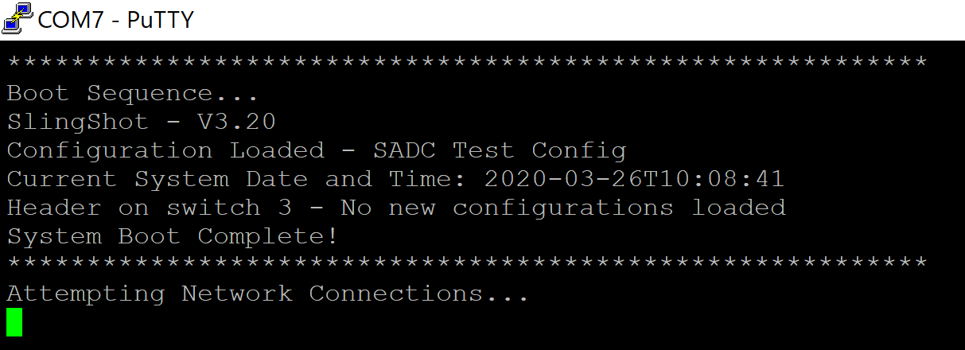
Figure 5 - Boot sequence
Hit any key to get the following menu.
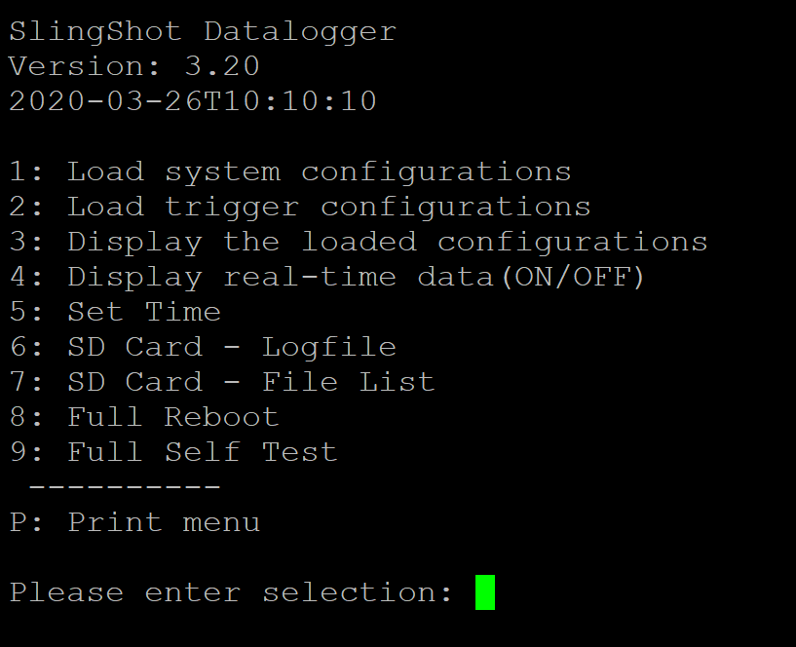
Figure 6 - Main Menu

Here is a brief description of the Main Menu items.

Number | Item | Description
1 | Load system configurations | This option loads in all the current ‘system’ configurations from the SD Card system.txt file. This is only needed once. It also automatically reboots after loading.
2 | Load trigger configurations | This option loads in all the current ‘trigger’ sensor configurations from the SD Card trigxx.txt files. This is only needed once. It also automatically reboots after loading.
3 | Display the loaded configurations | This option shows the current loaded ‘system’ and ‘trigger’ configurations that are loaded into the Tracelogger.
4 | Display real-time data (ON/OFF) | This option toggles (ON/OFF) between showing the real-time sampled sensor readings for checking operations.
5 | Set Time | This option is a method of manually setting the internal clock – use this is NTP fails or is not being used.
6 | SD Card - Logfile | This option allows the user to see the contents of the Log.txt (Logfile) of the SD Card – Use this for troubleshooting. You can also use this option to delete the Log.txt file.
7 | SD Card - File List | This option allows the user to see the file contents of the SD Card
8 | Full Reboot | This option allows the user run a full reboot without powering down.
9 | Full Self Test | This option runs a simple Self Test of the fitted sensors – Normally used by production staff to check the system.
P | Print menu | This option prints the Main menu again.

Configure the logger

To load the configurations (both System and Channel triggers) from the Terminal screen. Use options 1 and 2 from the terminal menu. Follow the on-screen menu and prompts.

Set date-time

Once the boot up has completed and if NTP (Time Server configuration has been selected) the logger will attempt to retrieve the correct data and time from the NTP time server. Next you can hit any key to get the main menu.
When you first use the logger or after a long period of time, it will be necessary to automatically or manual input the correct Date and Time. This can be done using a PC and the Terminal software. Use item 5 from the main menu and follow the on-screen prompts. A reboot is recommended after setting the time, but not essential.

Checking the system

Once the logger has been configured (both System and Channel triggers) and all sensors are connected. It is advisable to test the system locally before leaving the site. You can use the menu functions to display realtime data on the screen. To turn off the real-time data just select option 4 again (this option toggles ON/OFF this live readout).
Also, you will see a message when the Tracelogger starts to send a report (via HTTP or FTP) will happen in line with the programmed report period (in the System.txt file). You should also get a message when the message has been successfully sent (example shown in Figure 7).
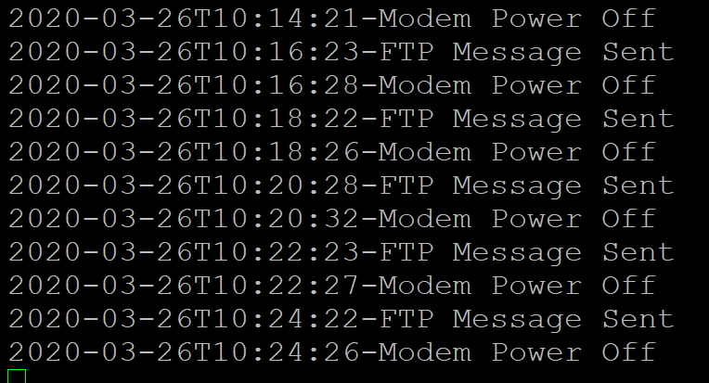
Figure 7 - FTP message sent example

Any problems please consult the troubleshooting section of this manual and check the configuration files.

Data collection

The Tracelogger is designed to be a remote data delivery platform, but occasionally you may need to collect the data manual (i.e. Communications problems or data checking). To do this you need to switch off the logger power and remove the lid of the Tracelogger. Then you can remove the SD Card. Using an SD Card reader of your choice, either cut and paste or copy and paste the data files from the card. They should be in daily timestamped CSV files.

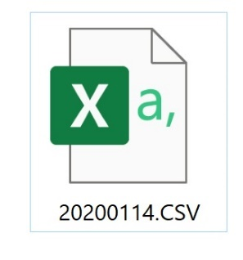
Figure 8 - SD Card data back-up file

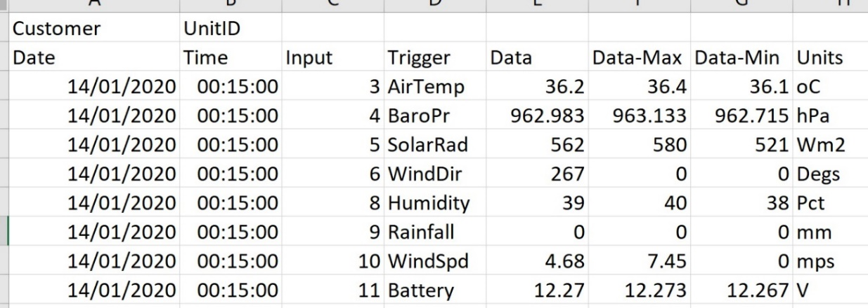
Figure 9 - Example of SD Card data format

It is also recommended to remove these back up data files every time you carry out site maintenance to prevent the SD Card from reaching full capacity – although this is unlikely.
Example: A typical Hydro-Met station set-up (as shown above) would create a daily CSV file of approximate 500kb in size.
Therefore, it would last for approximately 4Gb/500kb = 2000000kb/500kb = 8000 days of capacity. i.e. 20 years.

Appendix A - Frequently ask questions and Troubleshooting

FTDI driver auto installation

The USB cable provided with the Tracelogger is build using a FTDI chip. When the USB cable is first connected to a computer, Window Update will automatically detect the FTDI driver for the USB cable online and install it on the computer, if the driver is not already present. If no suitable driver is automatically found via Window Update, then the user should manually install the driver.
The FTDI drivers may be downloaded on the following link –
http://www.ftdichip.com/Drivers/D2XX.htm
The installation guide of FTDI driver for all Window operating system is available on the following link –
http://www.ftdichip.com/Support/Documents/InstallGuides.htm
The installation guide of FTDI driver for all Window 10 system is available on the following link –http://www.ftdichip.com/Support/Documents/InstallGuides/AN_396%20FTDI%20Drivers%20Installation%20Guide%20for%20Windows%2010.pdf
The installation guide of FTDI driver for all Window 8 system is available on the following link –
http://www.ftdichip.com/Support/Documents/AppNotes/AN_234_FTDI_Drivers_Installation_Guide_for_Windows_8.pdf
The installation guide of FTDI driver for all Window 7 system is available on the following link –
http://www.ftdichip.com/Support/Documents/AppNotes/AN_119_FTDI_Drivers_Installation_Guide_for_Windows7.pdf

System Troubleshooting

If the system is not fully working, first check the configuration settings by selecting menu 3. If an item is incorrect, reload the settings using option 1 and/or option 2.
If the system is still having problems – check the voltage levels using a multimeter at on the internal channels.
If the system is having problems communicating. Use the engineer debug mode. This is accessed by typing ‘d’ when at the normal menu. You will now see the direct feedback from the internal modem module.
If using a fibreglass mast system – make sure the individual bolts are tightened on each section before clipping the levers in place. This will avoid mast slippage when tightening the guy ropes.
For general weather station assembly – please refer to Trace2o video instructions.

Bootloader firmware upgrading

Occasionally it may be necessary to upgrade your Tracelogger system. This could be because of a minor bug in the firmware, an upgrade change to operations, new report formats or a network requirement. To make this easier for the user in the field we have designed a simple upgrade system using the SD Card and what is known as the preloaded internal bootloader software. Bootloader is only available on Tracelogger’s as standard from version 4.00 onwards.
Operation overview: When the Tracelogger is switched on (boots up) it automatically looks for a file on the SD Card (Loader.cfg). This file contains a version number of the Tracelogger firmware and other information as follows:
ID = 401

[PGM]
ERASE
Name = SSV401.hex

If this ID number matches the version number of the current firmware, no changes are made. If it does not match, and is greater than the Tracelogger version number, the logger goes into bootloader upgrade mode automatically. The next items in the Loader.cfg file tell the Bootloader what to do. In this case, ERASE all the Program Memory then load the new Program file “SSV401.hex”.
The following is the best procedure to follow to upgrade your system.
- Connect your Terminal software to the Tracelogger as normal (as described earlier in this manual).
- Power up the logger and make sure the menu functions and characters are appearing on the screen as normal.
- Switch off the logger power.
- Remove the SD Card from the logger and place in a PC Card Reader. Put the new Loader.cfg file and program hex file (in this case “SSV401.hex”) on the SD Card root directory (not in a folder). Replace any current Loader.cfg or Program hex file that is on the card.
- If you have been issued with new configuration files. Replace these on the SC Card as well. If not rename the configuration files folder (to “CfgV401” in this case).
- Put the SD Card back in the Tracelogger and turn on the power. You should now see the upgrade process begin on the Terminal screen. DO NOT TURN OFF POWER DURING THIS PROCEEDURE.
- Once the new Program firmware has been loaded you may need to reload the current new logger configuration files. This is done as before using the menu functions (1 and 2).
- The Tracelogger upgrade is now complete. Leave the Loader.cfg file and current program (.hex) file on the SD Card as the Bootloader will see this every time it powers up and know it is running the current version.

